**Defining Classes Labs – Part 1**

**Name**: Chi Ming Lai

**Student Number**: 158400200

**Section**: SYD366 ZAA

**Date**: 20-05-2022

**Professor**: Marc Gurwitz

**Email**: cmlai@myseneca.ca

**Group: 1**

This is an individual lab.

Read the attached Defining classes lab.

Your tasks:

1. Create a class diagram to support the case study and Systems Use Case Specifications

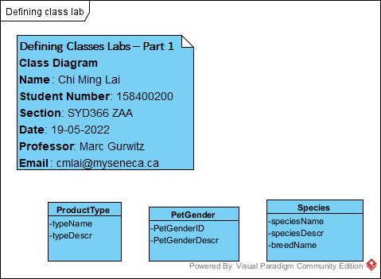

1. Create object level sequence diagrams for each of the query systems use case specifications
   1. Query all product types and their descriptions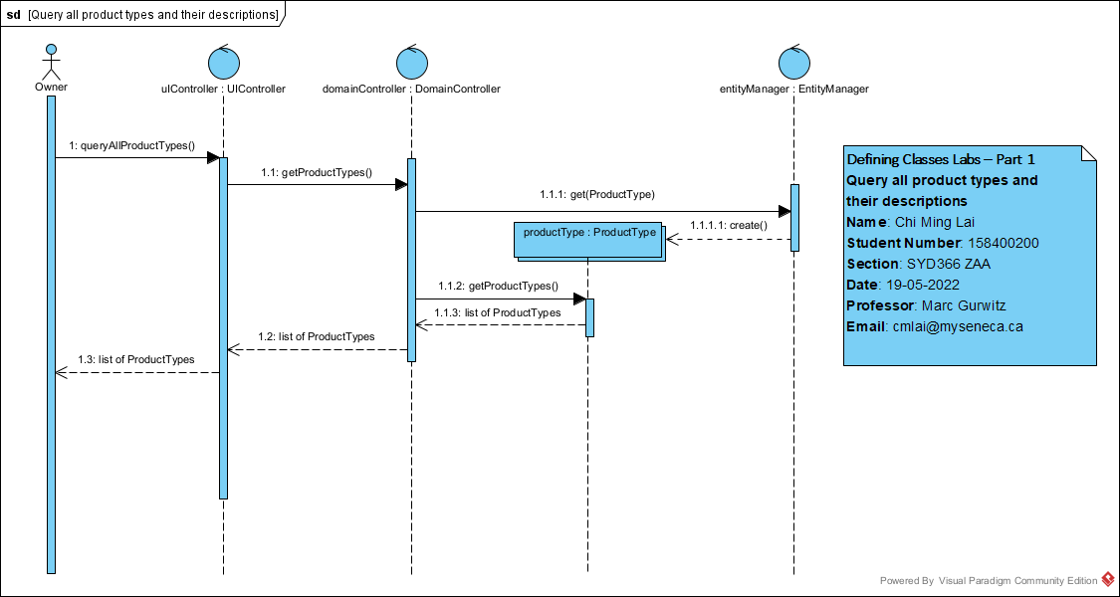
   2. Query all pet genders and their descriptions

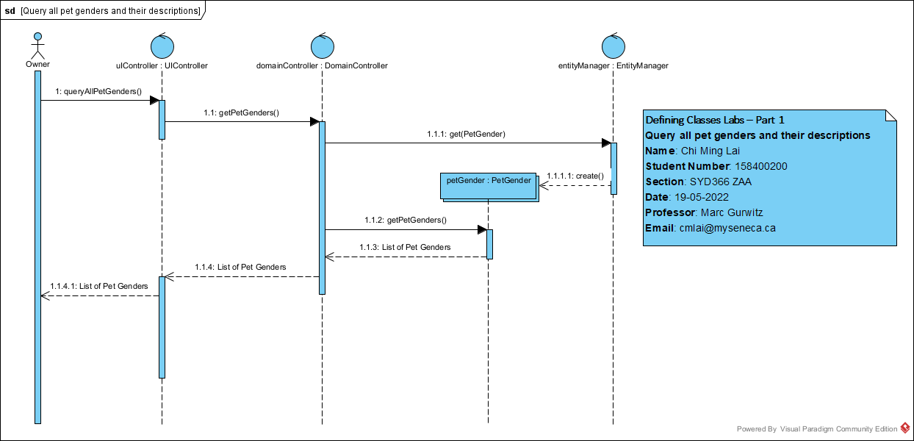

* 1. Query all species 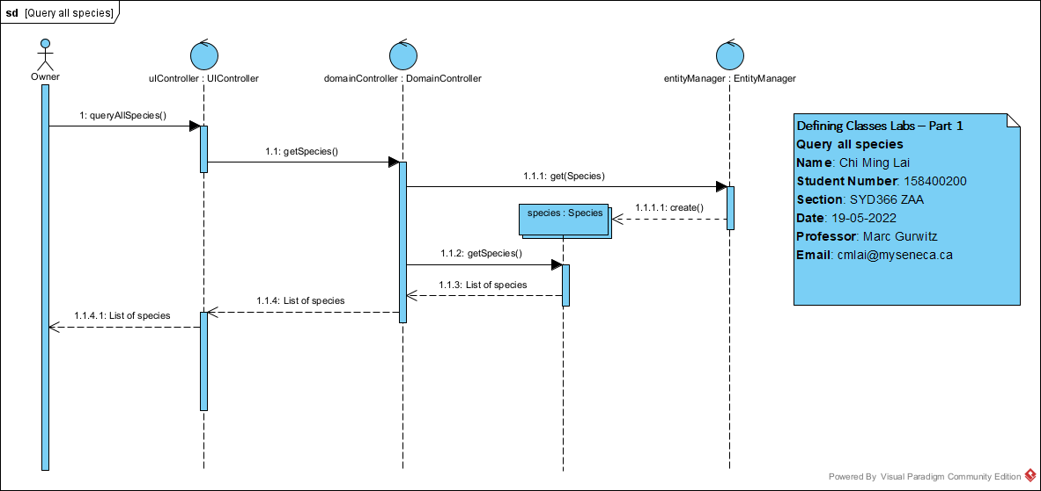

1. Copy and paste your diagrams into a .docx compatible file. Submit your .docx file along with your. vpp (visual paradigm) file.